Grinding in a mortar-pestle: A simple and eco-friendly route for the synthesis of cis-fused chromano[4,3-c]isoxazoles via intramolecular nitrone cycloaddition
Zigmee T. Bhutia, Anurag Malik, Geethika P., Amrita Chatterjee* and Mainak Banerjee*
Department of Chemistry, BITS Pilani-K. K. Birla Goa Campus, NH 17 B Bypass Road, Zuarinagar, Goa 403726 INDIA.
mainak@goa.bits-pilani.ac.in; amrita@goa.bits-pilani.ac.in

The development of efficient and environmentally friendly chemical processes for the preparation of biologically active and industrially useful molecules constitutes a major challenge for chemists in organic synthesis. A sustainable and “greener” method would focus on minimal to no use of solvents, reduction of other wastes, use of ambient conditions as well as shortening of reaction time, and developing more facile ways of product separation and purification. A mechanochemical process, which involves the input of mechanical energy for reactions such as grinding or ball-milling, facilitates most of the above mentioned features of sustainable methods and therefore, such strategies have emerged as attractive alternative to the traditional solution based synthetic methods [1]. Although “ball milling” has been used with great success for typical organic transformations such as aldol condensation, Michael additions, Knoevenegal condensation, Morita–Baylis–Hillman reactions, cross-coupling reactions, click reactions etc. “hand-grinding” technique is mostly limited to simple condensation reactions including Schiff base formation, oxime formation etc [1]. However, manual grinding with a mortar and pestle is a very useful method at laboratory scale due to simple and hazardless experimental set-up. Our current research endeavor is focused on utilizing this technique for the construction of heretoaromatic compounds of biological interest [2].
1,3-Dipolar cycloaddition is a classical reaction in organic synthesis for the construction of five membered ring fused heterocycles. In particular, intramolecular nitrone-olefin cycloadditions have been utilized to obtain structurally more complex bi- or tri-cyclic isoxazolidines of either biological significance or as useful synthetic intermediates for target molecules. In spite of their bioactivity and potential pharmacological utility not many methods have been developed for chromano-isoxazoles. Moreover, existing methods are based on conventional synthetic protocols involving use of hazardous reagents, toxic solvents or relatively harsh reaction conditions. However, green protocols for chromano-isoxazoles are rarely reported [3]. Current work focuses on the synthesis of tetrahydro-1H-chromano [4,3-c]isoxazoles by mechanical grinding in a mortar–pestle. The mortar-pestle grinding facilitates nitrone formation, which further undergo intramolecular 1,3-dipolar cycloaddition upon heating to produce chromano-[4,3-c]isoxazoles (Scheme 1).
In a typical procedure, O-allyl salisaldehyde (1 equiv.) and alkyl- or aryl-hydroxylamine (1.2 equiv.) were taken in an Agate mortar and Pestle and the reaction mixture was ground until the starting material was completely consumed (15-30 min). The reaction mixture was heated at 80 ºC for 2-4 hrs to get the desired chromano-[4,3-c]isoxazoles in excellent yields. The formation of the products was confirmed by determination of melting point, ¹H NMR, ¹³C NMR and ESI-MS.
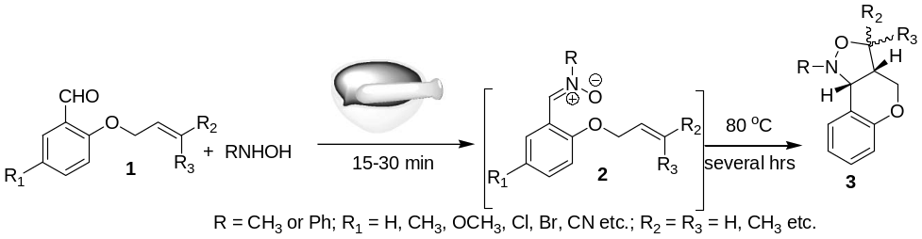
Scheme 1. Hand-grinding route for the synthesis of chromano-[4,3-c]isoxazoles via nitrone cycloaddition.
References:
- G.-W. Wang, Chem. Soc. Rev., 2013, 42, 7668.
- Banerjee et al. RSC Adv., 2014, 4, 39606.
- Chatterjee et al. Tetrahedron Lett., 2010, 51, 6700.

